VIER

Dave Maunish, Panchal Shrey, Gokhale Chaitanya

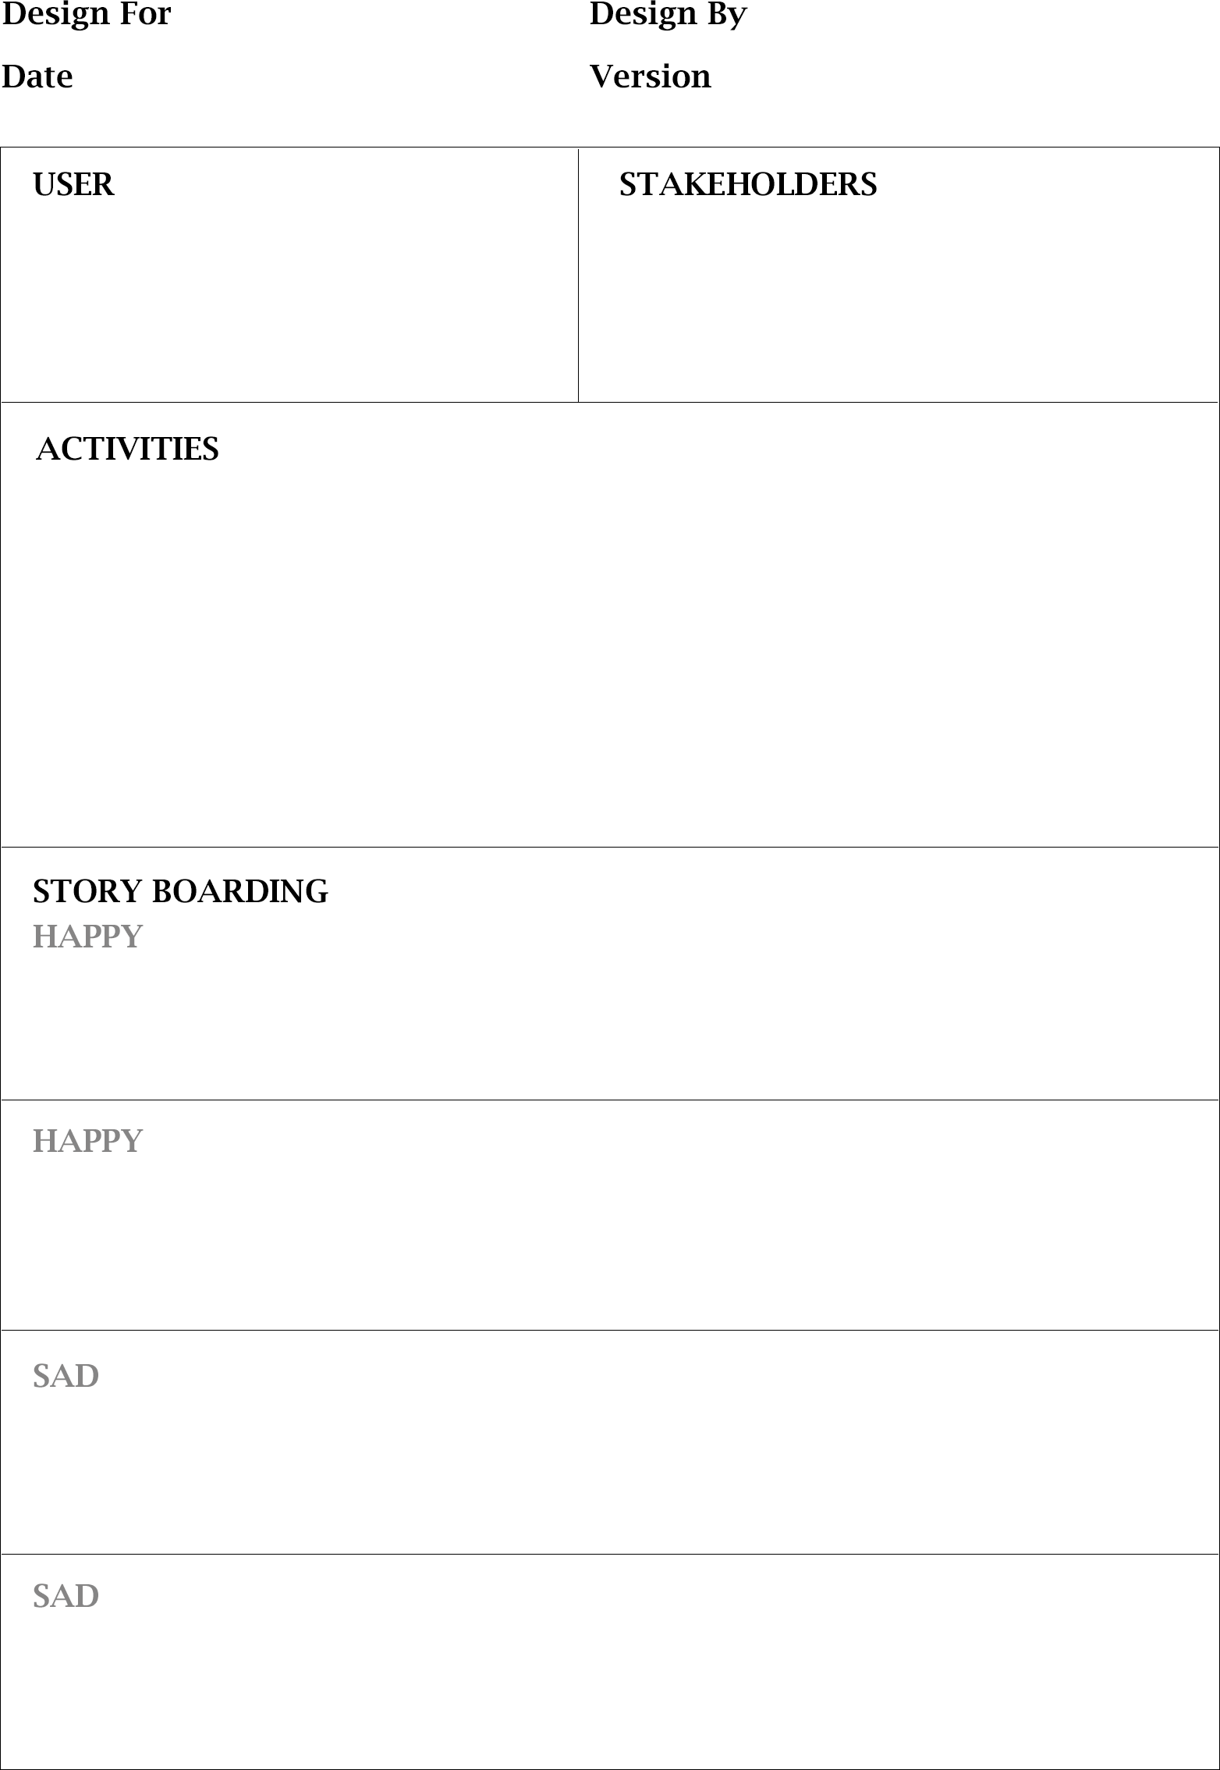

29/09/2020 1/1

Once Investor wanted to invest their excess funds to any business so, he installed an application for finding businessman. Investor found out a businessman in that app. Eventually, Investor transferred money to the Businessman and after some time he realised that was a fraud Businessman, he lost their money because that application did not contain Identifications of both the users so, because of less security investor lost their money.

Once my friend started business of Pest-control, staring eight months was quite good for him but at some point of time his funding got over, so he was searching for money to grow his business. He found an investor by a third- party android application, in that application doesn’t have security for transaction. As Investor send money to my friend, due to lack of security my friend did not got money in his account.

I am a businessman. I have a transport business i do transport locally as well as out of city and the huge portion of my investment money is used for gasoline. My drivers said that lot of the gas is wasted due to waiting in red traffic lights and sometimes they reach late due to that. But before sometimes thay

Every day when i went to office i used to get late due to traffic and due to red signals. I always thought that if there is no red signals i could reach office in time , well I know that is not possible but i heard that there is new algorithm city is using to control traffic lights and i realised it's results when i reached office early even though I left the home at same time.

Reinforcement learning

Deep learning

Object detection

Markov decision process

Municipal corporation

INVESTOR

Government

Tech companies

Government

Common people

Municipal corporation